MILLER, ARTHUR (1915-2005)

With a writing career stretching over six decades, including fiction, memoirs, and journals, as well as over two dozen plays, Arthur Miller’s contributions to American and world literature are significant. However, they are nowhere so strongly felt as in the field of drama, where his groundbreaking, now seminal, play Death of a Salesman (1949) had a profound impact, both stylistically and philosophically, on the future of American modernist theatre.

Born in New York City into a recently immigrant Jewish family who were beginning to live the American dream of success, Miller soon tasted the bitterness of loss as the Great Depression hit and destroyed his father’s prosperous clothing business. This event, later followed by the atrocities of the Holocaust, would strongly influence Miller’s modernist outlook on humanity as deeply flawed, though not without the possibility of redemption if attitudes could be changed. He spent his life trying to change those attitudes through his art.

Filled with socialist principles that in the late 1930s seemed to offer a kinder future, he attended the University of Michigan as an undergraduate, winning several prizes for playwriting. After graduation, he joined the Federal Theater Project to work on radio drama shortly before it was closed down. He continued to write radio plays that ran from conventional patriotic war sagas to the more quirky The Pussycat and the Plumber Who Was a Man (1940)—a comic exposé of political corruption. In 1940 he married his college girlfriend, Mary Slattery, with whom he would have two children, Jane and Robert. His first full-length play produced on Broadway—The Man Who Had All The Luck (1944)—did not last a week. The director had turned his fable of an individual’s quest for contentment into a naturalistic drama, and with this treatment it failed to capture the audience. Miller considered giving up on theatre, and successfully published a novel about American anti-Semitism: Focus (1945).

Miller was determined to break through in drama, however, and achieved theatrical success in 1947 with the relatively realistic play All My Sons, about a man who tried to cover up selling faulty aircraft parts to the airforce. This success gave him the license to be more experimental with his next play, Death of a Salesman, which covers the last day of Willy Loman’s life and presented American theatre with a new type of tragic hero. Willy is not the noble hero of Greek tragedy, but a relatively ordinary man whose tragic status is presented through his evident suffering yet refusal to admit defeat. A modernist indictment of the increasingly materialistic American Dream, Death of a Salesman exposes the fruitless and dehumanising quest for financial success that Willy misguidedly seeks. The protagonist’s uneasiness with technology emblematises his growing alienation from his society. The play’s intricate blend of realistic and expressionistic techniques, brought to life on stage by the innovative lighting and set design of Jo Mielziner and the dynamic direction of Elia Kazan, was able to effectively convey the simultaneity of past and present through Willy’s memory that Miller had sought to present.

The rejection of strict chronology in favor of looping time displayed in Death of a Salesman is a modernist concept to which Miller would return in several other works, including the semi-autobiographical plays After the Fall (1964) and Mr. Peter’s Connections (1997), as well as in his autobiography, Timebends: A Life (1978). These works display Miller’s existential search for a better faith, given what he came to see as humanity’s evident propensity for evil. Believing that evil could never be fully overcome, Miller determined that the best solution for the future was to acknowledge one’s guilt while continuing to assert one’s responsibility to others. These are the traits he would instill in future protagonists. After the resounding success of Death of a Salesman, which won a Pulitzer Prize and became the only play to be Book of the Month, Miller wrote a series of successful modern tragedies, including The Crucible (1953), A View from the Bridge (1956), The Price (1968), and Broken Glass (1994), as well as a variety of other plays, short fiction, and essays.

In 1956 Miller divorced his wife to marry Marilyn Monroe, for whom he would write the screenplay The Misfits (1961), about a group of people who briefly bond in their collective pain to create a supportive unit against an increasingly alienating world. His marriage to Monroe had collapsed by the time of filming, however, and after they divorced, he wed the photographer Inge Morath, with whom he would have two children, Rebecca and Daniel, and live happily for the next forty years. During this time, he grew more engaged with international politics and continued to experiment with form, from his imagistic short plays of the 1980s—Two-Way Mirror and Danger: Memory!—to his exploration of power in The Archbishop’s Ceiling (1977) and of an individual’s capacity for selfishness in The Ride Down Mt. Morgan (1991). He wrote in a variety of styles, but always with the same underlying message: people are almost universally flawed and prone to evil, but they can try to be better.

List of Works

Miller, Arthur. (2009) Miller Plays, vols. 1-6, London: A&C Black.

------ (1987) Timebends: A Life, New York: Grove, 1987.

------ (1995) Homely Girl, A Life and Other Stories, New York: Viking.

------ (1996) The Theater Essays of Arthur Miller, rev. ed., ed. Robert A. Martin and Steven R. Centola, New York: Da Capo Press, 1996.

------ (2000) Echoes Down the Corridor, ed. Steven R. Centola, New York: Viking.

------ (2001) Focus, New York: Penguin.

------ (2007) Presence: Stories, New York: Viking, 2007.

References and Further Reading

Abbotson, Susan C. W. (2008) Critical Companion to Arthur Miller, New York: Facts on File.

Bigsby, Christopher. (2008/2011) Arthur Miller 1915-1962/Arthur Miller 1962-2005, London: Weidenfeld & Nicolson.

------ (2005) Arthur Miller: A Critical Study, New York: Cambridge University Press.

Bigsby, Christopher, ed. (2010) The Cambridge Companion to Arthur Miller, 2nd ed., New York: Cambridge University Press.

Centola, Steven R., and Michelle Cirulli, eds. (2006) The Critical Response to Arthur Miller, Westport, CT: Praeger.

Koorey, Stefani. (2000) Arthur Miller's Life and Literature: An Annotated and Comprehensive Guide, Boston: Scarecrow Press.

Murphy, Brenda. ed. (2010) Critical Insights: Arthur Miller, Hackensack, NJ: Salem Press.

Susan C. W. Abbotson, Rhode Island College

Recommended Illustrations
[Note: Please use one of the two photos of Miller and both of the production photos if possible.]

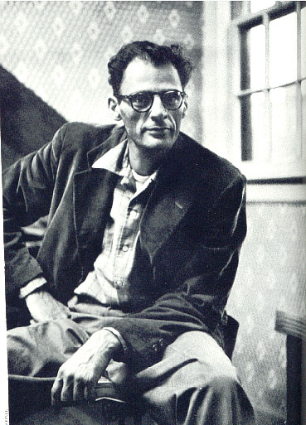

Arthur Miller
[Available at: http://bingweb.binghamton.edu/~ccarpen/Miller.htm ]

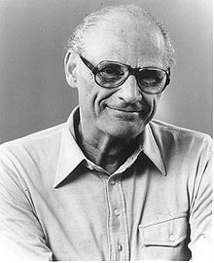

Arthur Miller
[Available at: http://en.wikipedia.org/wiki/Arthur_Miller ]

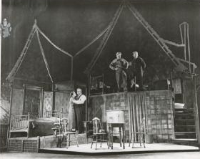
Mildred Dunnock, Lee J. Cobb, Arthur Kennedy, and Cameron Mitchell in a scene from the 1949 production Death of a Salesman designed by Jo Mielziner and directed by Elia Kazan.
[Available at: Billy Rose Theatre Collection, New York Public Library Digital Gallery, Image ID: ps_the_cd55_849]

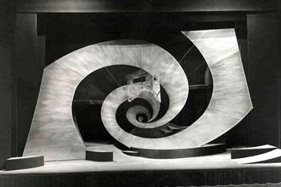
After the Fall, Cottesloe Theatre (1990). Designed by Hayden Griffin; set engineering, construction and painting by Kimpton Walker; additional painting by the National's workshops.
[Available at: http://www.nationaltheatre.org.uk/discover-more/archive/archive-collection-holdings/technical-photographs ]

